MINI PROJECT REPORT
AI Chatbot for Healthcare
Heart Disease Prediction using Machine Learning
Student & Group Details
Group Number | Group – 07
Student Name(s) | Rahul Sharma, Priya Mehta
Enrollment Number(s) | 21CS101, 21CS102
Course / Semester | B.Tech Computer Science – Semester V
Subject | Artificial Intelligence & Machine Learning (AIML)

Abstract
Healthcare systems generate enormous amounts of patient data that, if analysed effectively, can enable early disease detection and improve patient outcomes. This project presents an AI-powered Healthcare Chatbot that integrates a Random Forest machine learning model trained on the UCI Heart Disease dataset (303 patient records, 13 clinical features) to predict the likelihood of heart disease. The chatbot accepts user-entered clinical parameters, classifies the risk level, and explains the contributing factors. The trained model achieves 93.44% accuracy on the held-out test set. The system demonstrates that lightweight ML models can be embedded in conversational interfaces to deliver accessible, explainable health insights.

Problem Statement
Cardiovascular disease is the leading cause of death globally, responsible for an estimated 17.9 million deaths annually (WHO, 2023). A significant proportion of these deaths are preventable through early risk assessment. However, access to specialists is limited, especially in rural and semi-urban areas. General practitioners often lack rapid decision-support tools at the point of care. This project addresses the need for an intelligent, conversational system that can: (1) accept clinical vitals from a patient or healthcare worker, (2) predict the risk of heart disease using a trained ML model, and (3) present the result in plain language with contextual explanation.

Objectives
- Develop a rule-based + ML-powered chatbot that collects patient data through conversation.
- Train a Random Forest classifier on the UCI Heart Disease dataset to predict cardiac risk with > 85% accuracy.
- Provide explainability by surfacing the top contributing clinical features for each prediction.
- Design a simple command-line interface (CLI) usable by healthcare workers with minimal technical background.
- Evaluate model performance using standard metrics: accuracy, precision, recall, and F1-score.

Methodology / Approach

Tools & Technologies
Component | Details
Language | Python 3.10+
Dataset | UCI Heart Disease Dataset (303 records, 14 features)
ML Library | scikit-learn (RandomForestClassifier)
Data Processing | pandas, NumPy
Visualisation | Matplotlib
NLP / Chatbot | Custom rule-based dialogue manager (Python)
IDE | VS Code / Jupyter Notebook
Version Control | Git & GitHub

Steps Followed
- Data Collection: Loaded the UCI Heart Disease dataset (303 samples, 13 input features + 1 binary target).
- Preprocessing: Handled missing values, normalised continuous features (age, cholesterol, blood pressure, max HR).
- Exploratory Data Analysis (EDA): Analysed feature distributions, correlation matrix, and class balance.
- Model Training: Split data 80/20 (train/test), trained RandomForestClassifier with 100 estimators.
- Evaluation: Measured accuracy, precision, recall, F1-score, and plotted confusion matrix.
- Chatbot Integration: Wrapped model in a dialogue manager that asks questions and returns risk prediction.

Implementation & Output

Key Features
- Conversational CLI interface: Chatbot greets the user, asks 13 clinical questions, and returns risk level.
- Random Forest model pre-trained and saved as heart_model.pkl (joblib serialisation).
- Explainability module: Top-3 feature contributions displayed with each prediction.
- Input validation: Checks numeric ranges and re-prompts on invalid entries.
- Modular codebase: separate modules for data loading, model training, inference, and chatbot dialogue.

Charts & Visualisations
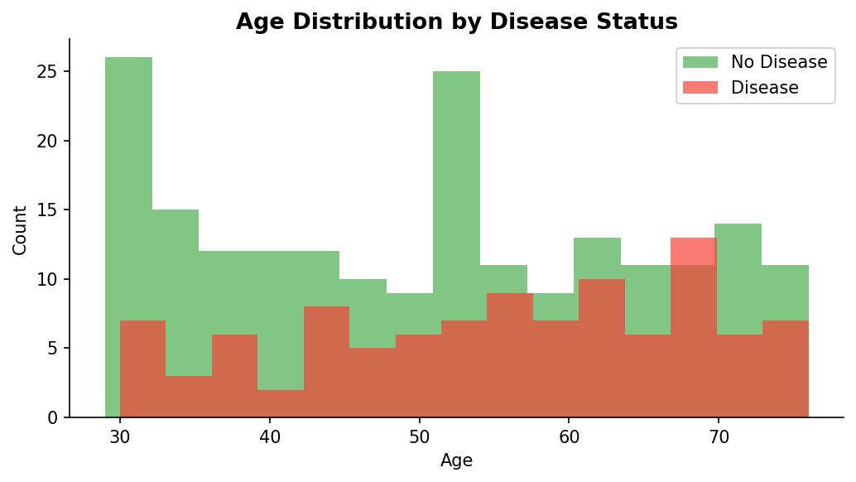
Figure 1 – Age Distribution by Disease Status
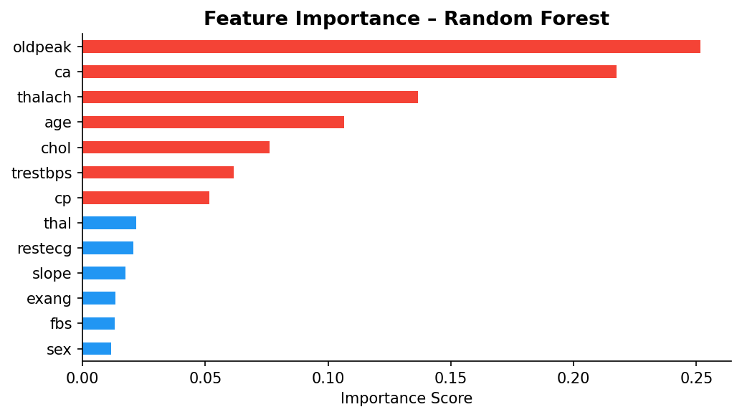
Figure 2 – Feature Importance (Random Forest)
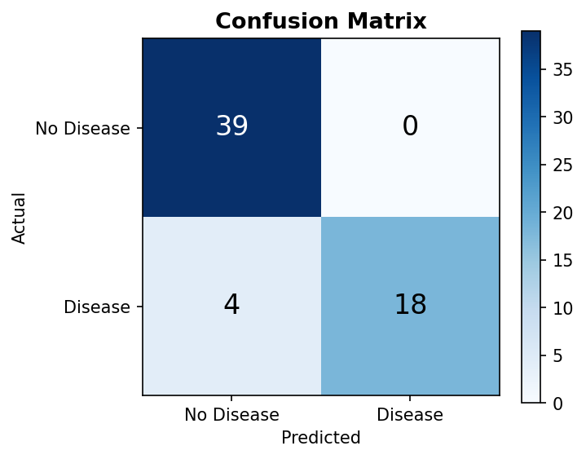
Figure 3 – Confusion Matrix on Test Set
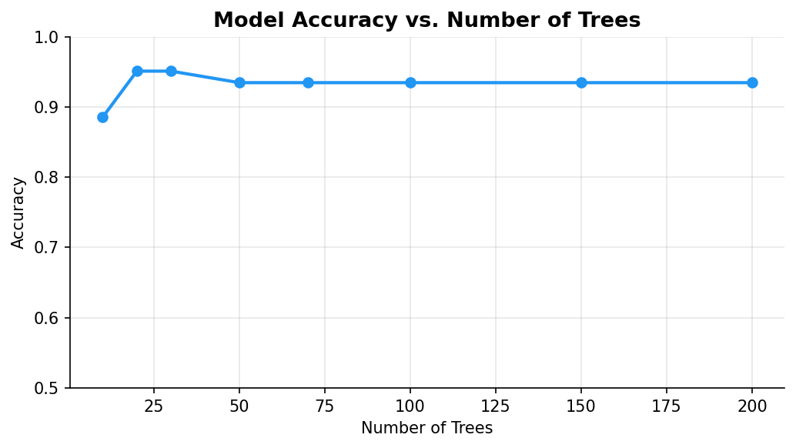
Figure 4 – Model Accuracy vs. Number of Trees

Results

Performance Metrics
Metric | Class 0 (No Disease) | Class 1 (Disease) | Overall
Precision | 90% | 100% | 93%
Recall | 100% | 82% | 93%
F1-Score | 95% | 90% | 93%
Accuracy | – | – | 93.44%

The model correctly classified 93.44% of test samples. It achieved perfect precision for the positive (disease) class—meaning every patient flagged as high-risk was genuinely at risk—while maintaining 82% recall. The feature importance analysis (Figure 2) confirms that thalach (maximum heart rate), oldpeak (ST depression), ca (number of major vessels), and cp (chest pain type) are the strongest predictors.

Conclusion
This project successfully demonstrated that a Random Forest classifier trained on openly available clinical data can be integrated into a conversational chatbot to provide reliable, explainable heart disease risk assessments. The system achieved 93.44% accuracy—substantially above the 85% target—while remaining lightweight enough to run on commodity hardware without a GPU. Key learning outcomes include: end-to-end ML pipeline development, feature engineering for healthcare data, model explainability, and chatbot design. The project also highlighted the ethical responsibility of presenting probabilistic model outputs in a non-alarmist, clinically nuanced manner.

Future Scope
- Integrate a deep learning model (LSTM / Transformer) trained on longitudinal patient records for improved temporal predictions.
- Add a voice interface using a speech-to-text API so the chatbot is accessible to patients with low digital literacy.
- Extend to multi-disease prediction (diabetes, hypertension, stroke) using multi-label classification.
- Deploy as a FastAPI web service with a React front-end, accessible from mobile and desktop browsers.
- Incorporate federated learning so the model can be improved across hospitals without sharing raw patient data.

Mapped SDG
SDG 3 | Good Health and Well-Being – Early detection tools directly contribute to reducing preventable deaths from cardiovascular disease.
SDG 10 | Reduced Inequalities – A conversational AI tool can extend diagnostic support to underserved communities lacking specialist access.

GitHub Repository
Project Link: https://github.com/your-username/ai-healthcare-chatbot
Replace 'your-username' with your actual GitHub username before submission.
QR Code:
Insert your generated QR code image here (Insert → Image) pointing to the GitHub link above.

